Platform Architecture Deep-Dive Report: Windows, Linux, and macOS

1. Windows Architecture & Internals
Windows NT uses a hybrid architecture that combines the speed of a monolithic kernel with the modularity of a microkernel design. It strictly separates operations into two primary access modes: User Mode and Kernel Mode.
+-------------------------------------------------------------------+
| USER MODE |
| +-------------------+ +-------------------+ +-------------+ |
| | Applications | | Protected Subsyst.| | Subsystem | |
| | (User Processes) | | (lsass, csrss) | | DLLs | |
| +-------------------+ +-------------------+ +-------------+ |
+------------------------------------+------------------------------+
| System Service Calls
+------------------------------------v------------------------------+
| KERNEL MODE |
| +-----------------------------------------------------------+ |
| | Executive Services | |
| | (Object Mgr, Process Mgr, Virtual Memory Mgr, I/O Mgr) | |
| +-----------------------------------------------------------+ |
| | Kernel (Thread scheduling, Interrupt dispatching) | |
| +-----------------------------------------------------------+ |
| | Hardware Abstraction Layer (HAL) | |
| +-----------------------------------------------------------+ |
+------------------------------------+------------------------------+
v
Physical Hardware

User Mode vs. Kernel Mode
- User Mode (Ring 3): Applications, subsystem dynamic-link libraries (DLLs), and integral subsystems execute here. Processes running in User Mode are assigned a private, virtual address space and cannot directly access hardware or critical system memory. If a user-mode process crashes, it is isolated and does not take down the entire operating system.
- Kernel Mode (Ring 0): The core operating system components, executive services, and device drivers execute here. Kernel mode code has unrestricted access to system hardware and all system memory. A failure or crash in a kernel-mode component results in a Bug Check (the Blue Screen of Death or BSOD).

Core Components
- Hardware Abstraction Layer (HAL): A low-level DLL (hal.dll) that hides platform-specific hardware differences (such as motherboard architectures or chipsets) from the operating system, providing a uniform interface.
- The Kernel (ntoskrnl.exe): Responsible for low-level operating system functions such as thread scheduling, interrupt and exception dispatching, and multiprocessor synchronization.
- Executive Services: Layered on top of the kernel, this encapsulates subsystems that manage core OS functions:
  - Object Manager: Creates, manages, and protects Windows NT objects (abstract data types representing resources like files, threads, and shared memory).
  - Process Manager: Creates and terminates processes and threads.
  - Virtual Memory Manager (VMM): Manages virtual address spaces, physical memory mapping, and paging.
  - I/O Manager: Dispatches device-independent I/O requests to hardware device drivers.
- Subsystems: Windows exposes API sets via environmental subsystems. The primary subsystem is Win32 (managed by csrss.exe and win32k.sys). Security validation is handled by the Security Subsystem (lsass.exe - Local Security Authority Subsystem Service).

The Windows Registry
The Registry is a hierarchical database used to store cryptographic data, hardware configuration, driver settings, system capabilities, and user preferences.

Hierarchical Structure (Hives)
The registry is split into five main logical trees, known as Root Keys:
Root Key | Alias | Description
HKEY_CLASSES_ROOT | HKCR | Stores file associations and COM object registration data. (Merged view of HKLM\Software\Classes and HKCU\Software\Classes).
HKEY_CURRENT_USER | HKCU | Stores configuration specific to the currently logged-in user. Loaded dynamically from the user's NTUSER.DAT file.
HKEY_LOCAL_MACHINE | HKLM | Contains system-wide configuration settings for hardware, software, security, and the system kernel.
HKEY_USERS | HKU | Contains configuration profiles for all loaded user profiles on the system.
HKEY_CURRENT_CONFIG | HKCC | Stores information about the hardware profile used by the local computer system at startup.

Storage on Disk
The Registry is stored in binary files called hives located primarily within %SystemRoot%\System32\config\.
- HKLM\SYSTEM $\rightarrow$ \SYSTEM
- HKLM\SOFTWARE $\rightarrow$ \SOFTWARE
- HKLM\SECURITY $\rightarrow$ \SECURITY
- HKLM\SAM $\rightarrow$ \SAM (Security Accounts Manager)
- User profiles store their specific settings in C:\Users\<username>\NTUSER.DAT.

Windows Services
Services are background execution applications that run independently of active user sessions, managed by the Service Control Manager (SCM) (services.exe).
- Service States: Services can exist in states such as STOPPED, START_PENDING, RUNNING, STOP_PENDING, and PAUSED.
- Startup Types:
  - Automatic: Starts during system boot.
  - Automatic (Delayed Start): Starts shortly after boot to optimize initial boot times.
  - Manual: Starts only when explicitly called by an application, user, or dependent service.
  - Disabled: Cannot be started by the system or user.
- Security Contexts: Services run under specialized system accounts:
  - LocalSystem: Highest privileges on the local machine; acts as the computer on the network.
  - NetworkService: Restricted privileges locally; acts as the computer identity on network resources.
  - LocalService: Restricted privileges locally; acts as an anonymous user on the network.

Windows Event Logs
The Windows Event Log service (eventlog) centrally tracks system execution events, application behavior, and security audits.
- Core Log Channels:
  - Application: Events logged by third-party or enterprise applications.
  - System: Events logged by Windows system components and drivers (e.g., driver failures, hardware issues).
  - Security: Audits authentication attempts, resource access, and security policy modifications. Controlled by local/group audit policies.
- Format: Modern event logs use the .evtx format, stored in %SystemRoot%\System32\Winevt\Logs\.
- Critical Event IDs for Auditing:
  - 4624: Successful Account Logon
  - 4625: Failed Account Logon
  - 4688: A new process has been created (Crucial for endpoint detection).
  - 7045: A new service was installed (Common persistence mechanism).

Scheduled Tasks
The Task Scheduler allows automated execution of routine tasks based on granular triggers.
- Architecture: Managed by the Schedule service, tasks are configured via XML definitions stored within %SystemRoot%\System32\Tasks\.
- Triggers: Can be time-based (e.g., daily at 3:00 AM), event-driven (e.g., on Event ID 4624), or lifecycle-driven (e.g., at user logon or system startup).
- Actions: The execution outcome, which can include launching an executable (Start a program), sending an email (deprecated legacy), or displaying a message (deprecated legacy).

NTFS (New Technology File System)
NTFS is the default, highly resilient file system for modern Windows operating systems.
- Master File Table (MFT): The structural core of an NTFS volume. Every file and folder on an NTFS volume contains at least one record within the MFT. Record 0 always defines the MFT itself ($MFT).
- Metadata Files: NTFS uses hidden files prefixed with a dollar sign to manage metadata:
  - $LogFile: Used for transaction logging to aid in file system recovery after a crash.
  - $Bitmap: Tracks clusters that are currently in use or free.
  - $BadClust: Tracks physically damaged sectors on the storage media.
- Journaling (USN Journal): The Update Sequence Number (USN) Journal tracks changes made to files and directories on the volume, allowing backup systems and indexing engines to quickly view historical modifications.
- Alternate Data Streams (ADS): Allows files to contain more than one stream of data. The default stream holds the standard text or binary payload. Additional streams can be attached (e.g., file.txt:secret.txt). Windows uses this to append Zone Identifier data (:Zone.Identifier) to files downloaded from the internet to mark them as untrusted.

PowerShell Fundamentals
PowerShell is an object-oriented task automation framework and scripting language.
Unlike traditional shells (like cmd.exe or Bash) that pass data as flat string streams, PowerShell pipes raw structural objects between commands. This eliminates the need for complex string parsing (like grep or awk) because attributes can be accessed directly.
- Cmdlets: Built-in small commands following a strict Verb-Noun naming convention (e.g., Get-Process, Set-Service).
- Execution Policies: A safety guardrail (not a security boundary) that controls the conditions under which PowerShell loads files for execution:
  - Restricted: No scripts can be run. Default for older versions.
  - AllSigned: Only scripts signed by a trusted publisher can execute.
  - RemoteSigned: Locally written scripts can run; downloaded scripts must be signed by a trusted publisher.
  - Bypass: Nothing is blocked, and no warnings are shown.

2. Linux Architecture & Internals
Linux utilizes a monolithic architecture where all core OS components, such as memory management, process orchestration, filesystem drivers, and hardware interactions, execute entirely within a unified kernel space.
+-------------------------------------------------------------------+
| USER SPACE |
| +-----------------------+ +---------------------------+ |
| | User Applications | | Standard C Library (glibc)| |
| +-----------------------+ +---------------------------+ |
+-------------------------------------------------------------------+
| SYSTEM CALL INTERFACE |
+-------------------------------------------------------------------+
| KERNEL SPACE |
| +-----------------------------------------------------------+ |
| | Process Management (O(1) / CFS Scheduler) | |
| +-----------------------------------------------------------+ |
| | Memory Management (Virtual Memory, Paging, Slabs) | |
| +-----------------------------------------------------------+ |
| | Virtual File System (VFS) | |
| +-----------------------------------------------------------+ |
| | Device Drivers & Network Stack | |
| +-----------------------------------------------------------+ |
+------------------------------------|------------------------------+
|
v
Physical Hardware

Monolithic vs. Microkernel Design
- Monolithic (Linux): High performance due to execution within a shared address space, removing IPC (Inter-Process Communication) context-switching overhead. Modularity is achieved using Loadable Kernel Modules (LKMs), which allow drivers to be dynamically inserted or removed from kernel memory without restarting the OS.
- System Call Interface (SCI): The explicit boundary layer separating user space from kernel space. When a user-space application requires a restricted operation (e.g., reading a file), it executes an interrupt instruction shifting execution control to the SCI, which safely executes the task inside kernel space.

Filesystem Hierarchy Standard (FHS)
Linux systems organize structural components and runtime directories based on a unified convention defined by the FHS:
- /: The structural root directory of the entire filesystem layout.
- /boot: Houses bootloader static configuration files, the initialization RAM disk (initramfs), and the Linux kernel image (vmlinuz).
- /etc: Central repository for host-specific static system configurations. No binaries may reside here.
- /var: Contains variable data files that dynamically change during runtime (e.g., persistent log paths /var/log/, spool directories, and application caches).
- /proc: A pseudo-filesystem tracking transient process configurations and kernel runtime metrics as abstract text representations (e.g., /proc/cpuinfo, /proc/sys/net/).
- /sys: An exported view of modern hardware subsystems, driver states, and device configurations.
- /dev: The hardware node access interface mapping physical and logical system devices to access pathways (e.g., /dev/sda for a storage disk, /dev/urandom for random byte streams).

Linux Permissions
Linux operates on a simple, discrete permission paradigm where file system assets are managed across three ownership scopes: Owner (User), Group, and Others.

Standard Permissions (rwx)
Permissions map directly to octal values or symbolic notations:
Permission | Symbolic | Octal | Effect on Files | Effect on Directories
Read | r | 4 | View contents of the file. | List files inside directory (ls).
Write | w | 2 | Modify file contents. | Add, delete, or rename files inside directory.
Execute | x | 1 | Run file as an executable code or binary. | Traverse or change directory into it (cd).

Special Permissions
- SUID (Set Owner User ID - Octal 4000): When placed on an executable file, users executing the binary temporarily inherit the execution privileges of the file's owner (e.g., /usr/bin/passwd running as root).
- SGID (Set Group ID - Octal 2000): On a file, executes with the group privileges of the file. On a directory, any new file or sub-directory created within inherits the parent directory's group ownership rather than the creating user's default group.
- Sticky Bit (Octal 1000): Applied to directories (e.g., /tmp). Restricts file deletion within that directory; only the file owner, directory owner, or root user can delete or rename the files.

Systemd
systemd is the modern initialization system and system service manager adopted by major distributions, replacing legacy SysV init schemes.
- PID 1 Lifecycle: As the first process spawned by the kernel during the boot sequence, systemd handles concurrent initialization of system units, manages dependency mapping, and cleans up orphaned runtime processes.
- Unit Types: Configuration is declared in descriptive configuration records called unit files:
  - .service: Controls background daemon runtime tracking and environmental controls.
  - .target: Groups related structural checkpoints or operational modes (e.g., multi-user.target represents non-graphical multi-user network initialization; replaces SysV runlevels).
  - .timer: Implements scheduled executions similar to cron, utilizing high-resolution kernel timers.
- Service Control Mechanics:
  - systemctl start <unit>: Launches a service immediately.
  - systemctl enable <unit>: Creates symlinks to start the service automatically at boot.

Package Management
Package managers automate the installation, updates, and dependency tracking of pre-compiled binary software suites.
- Debian/Ubuntu Archetype: Low-level package interaction is handled by dpkg using .deb archives. Advanced dependency resolution and repository retrieval are automated via the APT (Advanced Package Tool) framework (apt-get, apt).
- RedHat/CentOS/Fedora Archetype: Low-level operations rely on rpm interacting with .rpm packages. High-level automated lifecycle management and mirror negotiation are handled by DNF (Dandified YUM) or legacy YUM.

Bash Fundamentals
The Bourne Again Shell (Bash) serves as the primary text-based command interpreter interface for Unix-like environments.
- Pipes (|): Passes the standard output (stdout) of one process directly as the standard input (stdin) of an adjacent process.
- Redirection:
  - >: Overwrites a target file with output.
  - >>: Appends output to the end of a file.
  - 2>: Isolates and redirects standard error streams (stderr).
- Text Processing Pipelines:
  - grep: Filters input streams matching specified regular expressions.
  - awk: A text processing engine structured around analyzing column-delimited fields.
  - sed: A stream editor used to transform or substitute text inside data streams dynamically.

Secure Shell (SSH)
SSH provides an encrypted channel for secure network communications over unsecured infrastructures.
- Cryptographic Authentication:
  - Asymmetric Keypairs: Composed of a private key (stored safely by the client) and a public key (appended to /home/user/.ssh/authorized_keys on the remote system).
  - The Handshake: The server utilizes the client's public key to encrypt a challenge token during negotiation. The client must decrypt this token utilizing its matching private key, establishing verified identification without transmitting credentials across the wire.
- Hardening Directives (/etc/ssh/sshd_config):
  - PermitRootLogin no: Blocks immediate administrator access exposure.
  - PasswordAuthentication no: Enforces strict asymmetric key-only access validation.
  - Port <custom_integer>: Changes the default port (22) to mitigate automated scanning noise.

3. macOS Architecture & Internals
macOS is built on top of a POSIX-compliant Unix core called Darwin. This foundational stack integrates Apple-developed technologies with open-source components.
+-------------------------------------------------------------------+
| USER SPACE |
| +-----------------------+ +---------------------------+ |
| | Applications (Swift/ | | Frameworks (Cocoa, | |
| | Objective-C) | | CoreFoundation) | |
| +-----------------------+ +---------------------------+ |
+-------------------------------------------------------------------+
| DARWIN SYSTEM INTERFACE |
+-------------------------------------------------------------------+
| XNU KERNEL ARCHITECTURE |
| +-----------------------------------------------------------+ |
| | Mach Microkernel Component | |
| | (Tasks, Threads, IPC, Virtual Memory Messaging) | |
| +-----------------------------------------------------------+ |
| | BSD Layer (POSIX Compliance, VFS, Process Model, Network) | |
| +-----------------------------------------------------------+ |
| | I/O Kit / DriverKit (Object-Oriented Device Drivers) | |
| +-----------------------------------------------------------+ |
+-------------------------------------------------------------------+
v
Apple Silicon / Intel

XNU Kernel Architecture
The defining structural characteristic of Darwin is its hybrid kernel named XNU ("X is Not Unix"). XNU blends the clean logical abstractions of a microkernel with the raw execution performance of a monolithic system.
- Mach Component: The foundational core handling low-level duties: CPU thread scheduling, task isolation, multi-core synchronization, and the virtual memory messaging subsystem (vm_map). Mach uses Inter-Process Communication (IPC) based on message passing via message ports.
- BSD Layer: Built directly on top of Mach, this layer abstracts Mach's low-level components into a POSIX-compliant environment. It implements the standard Unix process model (PIDs), signals, basic security policies, networking stacks, and the Virtual File System (VFS).
- I/O Kit & DriverKit: The object-oriented framework utilized to implement device drivers. Modern macOS systems run drivers in user space using DriverKit to prevent faulty third-party code from causing kernel panic crashes.

Launch Services
Launch Services is a core framework that governs how applications are opened and registers their supported document formats and URL schemes.
- Application Bundles (.app): Unlike flat binaries, a macOS application is a structured directory hierarchy disguised as a single file. The primary layout includes:
  - Contents/MacOS/: Contains the actual compiled executable binary.
  - Contents/Resources/: Stores application interface graphics, localized translation files, and assets.
  - Contents/Info.plist: The fundamental information property list XML detailing application identity, version configurations, and structural declarations.
- Launchd Demultiplexing: launchd is the initialization framework replacing standard init infrastructures, functioning similarly to systemd. It handles daemon orchestration using job definitions placed in designated system hierarchies:
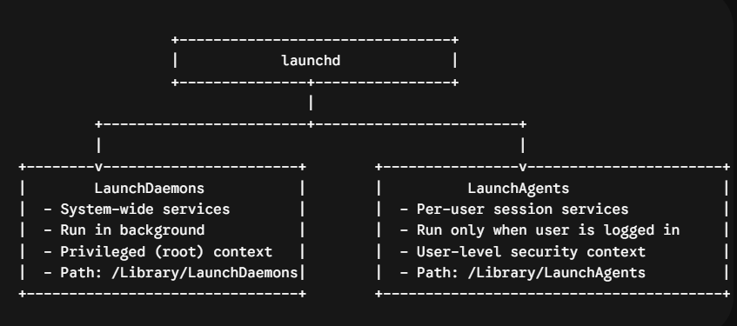

Keychain Services
The Keychain architecture serves as a secure, built-in storage container framework for passwords, digital certificates, cryptographic keys, and sensitive configuration strings.
- Storage Paradigms: Keychains store entries categorized into specific classes (such as internet passwords, generic passwords, certificates, or keys). Each item contains unencrypted attributes (such as account name, creation time, and server domain) used for searching, while the actual secret payload remains fully encrypted.
- Security & Encryption Frameworks: Modern Apple Silicon hardware enforces keychain security by integrating data protection mechanics directly into the physical hardware layer:
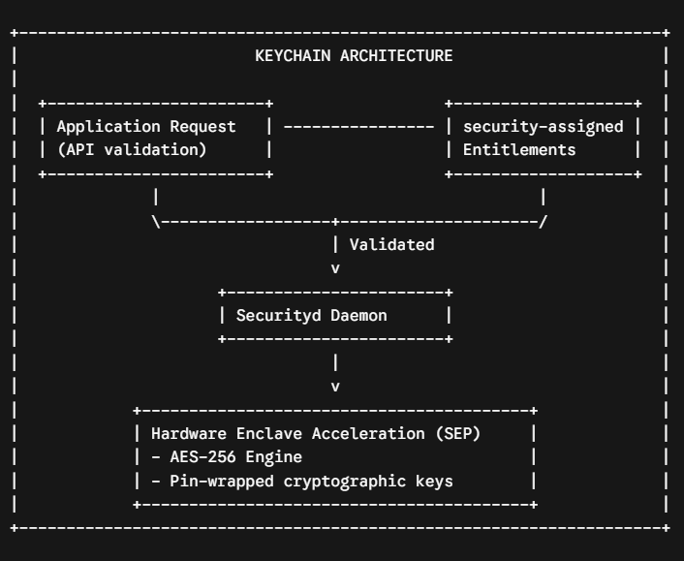
- The Securityd Daemon: User applications never read raw keychain files directly from the disk database. Instead, they send query API calls to the system's securityd daemon.
- Entitlement Verification: The securityd daemon inspects the requesting binary's embedded code signature and entitlements to verify if it has permission to access the requested item.
- Secure Enclave Processor (SEP): The actual master cryptographic encryption keys required to decrypt the keychain contents are tied directly to the hardware's Secure Enclave Processor. This protects the data from unauthorized inspection, even if kernel memory is compromised.

4. Architectural Comparison Dashboard
This table summarizes the core differences between the three operating system architectures:
Architectural Component | Windows Architecture | Linux Architecture | macOS Architecture
Kernel Type | Hybrid (ntoskrnl.exe) | Monolithic (Linux Kernel) | Hybrid (XNU / Mach + BSD)
Primary Init System | Service Control Manager | systemd (PID 1) | launchd (PID 1)
System Configuration | Central Registry (Binary Hives) | Flat text configuration files (/etc) | Property Lists (.plist in XML/Binary)
Default Filesystem | NTFS | ext4 / XFS | APFS (Apple File System)
Process Separation | User Mode (Ring 3) vs. Kernel Mode (Ring 0) | User Space vs. Kernel Space | User Space vs. Kernel Space
Privilege Escalation | UAC / Token Impersonation | SUID / sudo / Capabilities | sudo / TCC / Authorization Services
Package Management | None native (Winget overlay) | apt (Debian) / dnf (RedHat) | Bundled App / Native Installer (.pkg)

5. Summary Matrix: Key Commands for System Administration
Task | Windows (PowerShell) | Linux (Bash) | macOS (Zsh/Terminal)
View Running Processes | Get-Process | ps aux or top | ps -ef or top
Manage Services | Start-Service / Stop-Service | systemctl start|stop | launchctl load|unload
Inspect System Logs | Get-WinEvent | journalctl -xe | log show
Modify File Permissions | Set-Acl | chmod / chown | chmod / chown
View Network Connections | Get-NetTCPConnection | ss -tulpn or netstat | netstat -an or lsof -i

